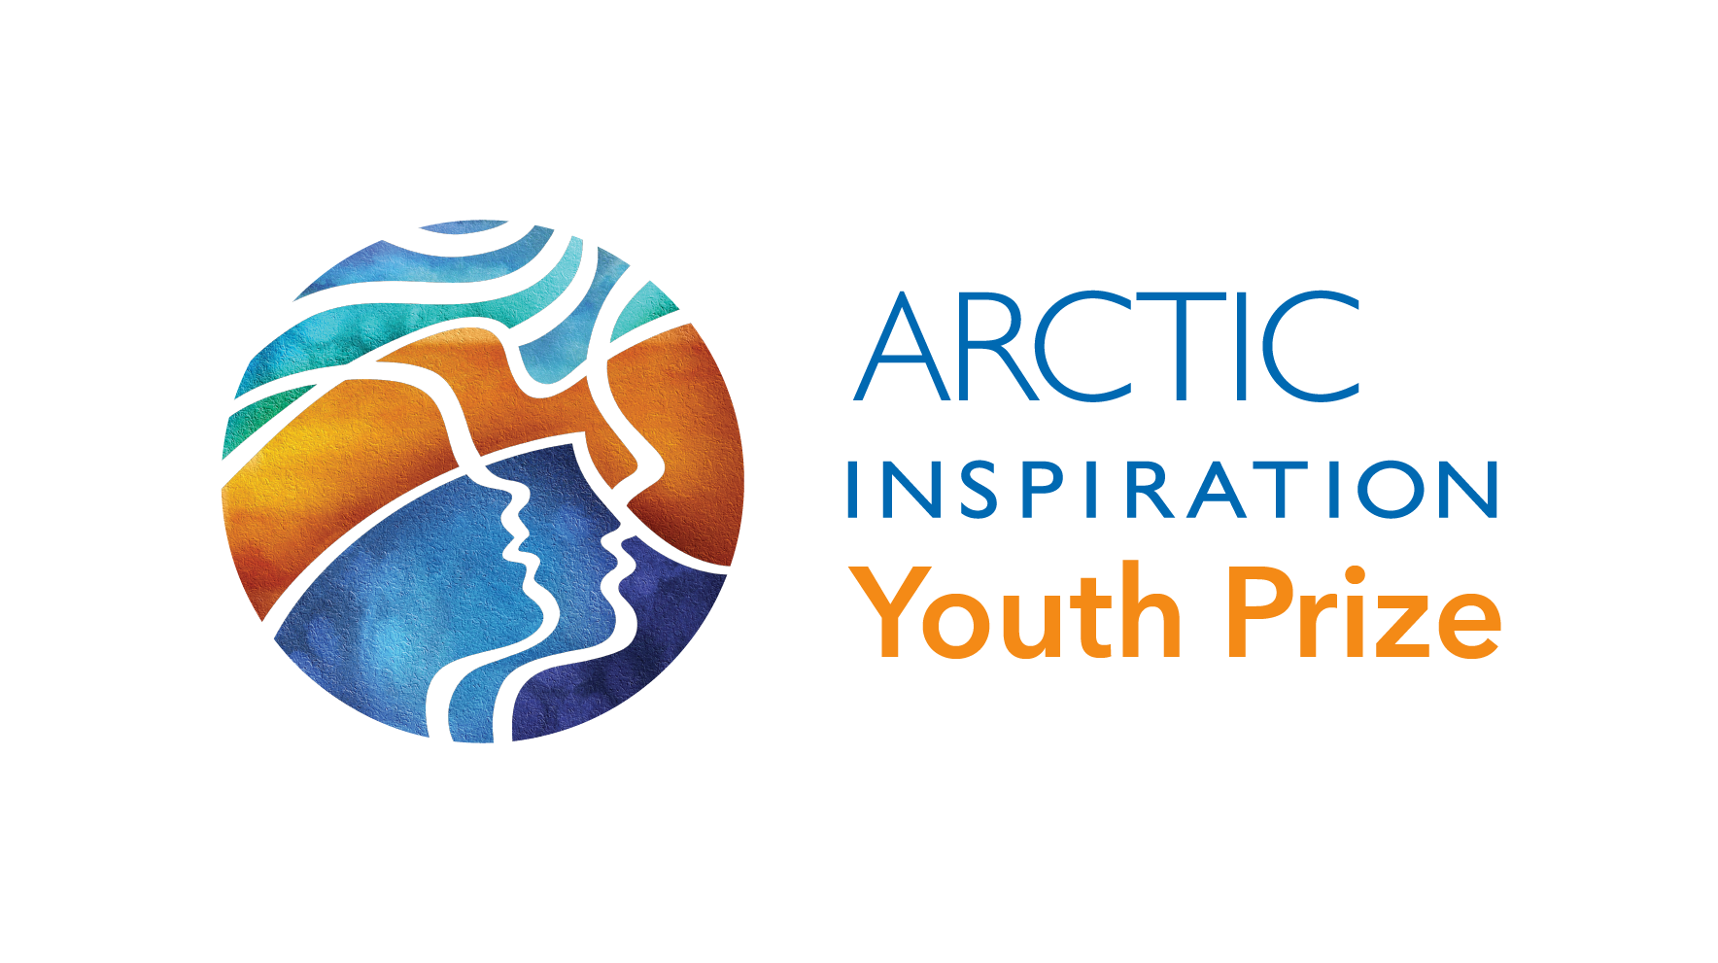
Nomination Template 2025
Thank you for deciding to submit a nomination to the Arctic Inspiration Youth Prize! We look forward to learning more about your project and team, and the positive changes you can make in your community and across the North.

The Nomination Template is divided into four sections:
- Section 1: Nomination Letter
- Section 2: Administrative Information and Budget
- Section 3: Project Information
- Section 4: Letters of Recommendation and Partner Support
(if applicable)

While Sections 1 and 2 must be completed in writing, you have the option to answer the questions in Section 3 in writing or in a video.
Write your answers directly into this template and make sure you answer all questions.
Only completed nominations will be accepted.

Table of Contents
- Nomination Checklist
- Section 1: Nomination Letter
- Section 2: Administrative Information and Budget
- 2.a Administrative Summary
- 2.b List and Role of Team Members
- 2.c Project Execution Plan and Expected Outcomes
- 2.d Budget
- 2.e Budget Justification
- 2.f Accountability of Project Execution
- 2.g Checklist
- Section 3: Project Information
- 3.a Project Objectives and Summary
- 3.b Activities and Results
- 3.c Knowledge Base
- 3.d Sustainability
- 3.e Communications
- 3.f How did we learn about the AIP?
- Section 4: Letters of Recommendation and Partner Support
- Letters of Recommendation
- Letters Confirming Partner Contributions

Nomination Checklist
When completing each section:
- Follow the detailed description.
- Keep it in order.
- Do not go over the word counts for each section.
- If you use any acronyms, make sure you tell us what they mean.

Section |  |  | Limits
□ | 1. | Nomination Letter | 1 page
 | 2. | Administrative Information and Budget
□ | 2.a | Administrative Summary | n/a (table)
□ | 2.b | List and Role of Team Members | 150 words per team member
□ | 2.c | Project Execution Plan and Expected Outcomes | 500 words
□ | 2.d | Budget | n/a (table)
□ | 2.e | Budget Justification | n/a (table)
□ | 2.f | Accountability of Project Execution | 250 words
□ | 2.g | Checklist | n/a (checklist)
 | 3. | Project Information
□ | 3.a | Project Objectives and Summary | 250 words or 60 seconds
□ | 3.b | Activities and Results | 500 words or 2 minutes
□ | 3.c | Knowledge Base | 250 words or 60 seconds
□ | 3.d | Sustainability and Lasting Impact | 200 words or 45 seconds
□ | 3.e | Communications | 200 words or 45 seconds
□ | 3.f | How did we learn about the AIP | 75 words or 15 seconds
 | 4. | Letters of Recommendation and Partner Support
□ | 4.a | Letters of Recommendation | Maximum of 5 (1 page each)
□ | 4.b | Letters Confirming Partner Contributions | n/a (if needed)

Section 1: Nomination Letter
Maximum 1 page
Attach a nomination letter. This letter must:
- Be an original document signed by both your Official AIP Ambassador/Nominator and Team Leader
- Include brief information about your Ambassador/Nominator
- Outline your Ambassador/Nominator’s rationale for nominating the project and team

In signing the letter, your Ambassador/Nominator confirms that the nominated team (1) has the capacity to carry out the proposed project, (2) that the project is relevant for the North, and (3) that the initiative will have impact in the target community or communities.

Remember: Your Ambassador/Nominator cannot be connected to the project and team in any way. Projects nominated by team members, individuals from connected organizations or groups, or individuals who are in any way connected to the activities, outputs, funding, or management/administration of the project will not be eligible.

Section 2: Administrative Information and Budget

2.a Administrative Summary

Please complete all the fields in the summary table below:
Project Title
Prize Category | Arctic Inspiration Youth Prize
Team Leader  Who is the Team Leader? | Name:  Title/Position/Organization:  Mailing Address:  Email Address:  Phone Number:
Ambassador/Nominator  Who is nominating your project? | Name:  Title/Position/Organization:  Mailing Address:  Email Address:  Phone Number:
Geographic Scope
What is the community (or communities) and region/regions of the Canadian Arctic where your project will take place and have impacts?

Remember: Proposed projects are required to be carried out and have impact within the regions eligible for the Arctic Inspiration Youth Prize: Yukon, Northwest Territories, Inuvialuit Settlement Region, Nunavut, Nunavik, and Nunatsiavut.
Total Project Cost
This amount includes both the prize money requested from the Youth Prize plus any additional cash or in-kind contributions from partners and/or team members.
Total Amount Requested from the Arctic Inspiration Youth Prize
Remember: This can be any amount up to a maximum of $100,000.

2.b List and Role of Team Members
Maximum 150 words per team member
Using the table below (add rows as required), list the team members for the project including the following information.
Name and Contact Info | Description | Date of Birth  (for youth members)
Name:  Mailing address:  Phone number:  Email: | - Description of role  - Relevant experience, knowledge, skills | Month xx, xxxx
Name:  Mailing address:  Phone number:  Email: | - Description of role  - Relevant experience, knowledge, skills | Month xx, xxxx
Note: If working with vulnerable peoples and selected as a Laureate, all team members listed here will be required to complete an enhanced criminal record check via the Arctic Inspiration Youth Prize.

2.c Project Execution Plan and Expected Outcomes
Maximum 500 words
The proposed project plan, as outlined in the sections below, should be developed in collaboration with project partners (if there are any).

The plan, outlining the proposed activities, should include:
- Timelines and expected completion dates.
- The geographical scope of project activities where the activities will take place.
- Project activities.
- The expected results.

2.d Budget
Complete the following budget table.
Project Duration:  <month, year> to <month, year> | Total  Cost | Team and Partner Contributions |  | Amount Requested from the Arctic Inspiration Youth Prize
Items | (Cash + In-kind + Amount requested from AIP = Total cost) | Cash | In-kind
1. Salaries & Benefits
- Team members
- Other salaries (please specify)
Total Salaries & Benefits
2. Equipment/Facility
- Purchase or rental
- Operating costs
Total Equipment/Facility
3. Materials & Supplies (please specify)
  - (please specify)
Total Materials & Supplies
4. Travel
- Meetings
- Team representatives to attend the awards ceremony in 2025 (Ottawa)
- Other (please specify)
Total Travel
5. Communications (please specify)
- Workshops/Meetings
- Other (please specify)
Total Communications
6. Project Activities (excluding workshops and meetings)
- (please specify)
Total Project Activities
7. Other Items
- (please specify)
Total Other Items
SUBTOTALS
8. Impact Assessment $4000* | $4000 |  |  | $4000
TOTAL

*The Youth Prize will retain an amount of $4000 of the total prize amount requested from the AIP to conduct an impact visualization/evaluation of the winning projects. The results of the visualization will be made available to winning teams. You can use it to fundraise from Sustainability Partners, governments, and others.

2.e Budget Justification

To better understand your budget, provide us with a justification and detailed breakdown for each amount in the budget table.
• Include an explanation of cash and in-kind contributions from partners/team members.
• Make sure that each amount mentioned in the budget justification corresponds to the same amount in the budget table.
• Keep the descriptions brief but descriptive.
Partners and organizations that have committed cash and/or in-kind contributions (as noted in the project budget) have to provide letters confirming their support (see Section 4.B).
If needed, partners or organizations can note in their letters that the contributions are conditional on the team winning the Arctic Inspiration Youth Prize.

Justification to be completed:
Items | Justification/Breakdown/Description/Notes
1. Salaries & Benefits
- Team members
- Other salaries (please specify)
2. Equipment/Facility
- Purchase or rental
- Operating costs
3. Materials & Supplies (please specify)
  - (please specify)
4. Travel
- Meetings
- Team representatives to attend the awards ceremony (location TBC)
- Other (please specify)
5. Communications (please specify)
- Workshops/Meetings
- Other (please specify)
6. Project Activities (excluding workshops and meetings)
- (please specify)
7. Other Items
- (please specify)

2.f Accountability
Maximum 250 words

- Details on how the project will be managed.
- How the team will oversee the finances of the project and what northern entity will receive the Youth Prize Laureate prize funds.
- How progress towards expected outcomes will be monitored.
- How the project will keep project stakeholders/partners and team members informed and/or connected.

2.g Checklist

- The entity that is nominated for the Arctic Inspiration Youth Prize (the Nominee) and would receive the Youth Prize funds is required to be northern. Non-northern entities, even with a project in the north, are not eligible. Note that this does not mean that southern individuals or organizations cannot be part of the project team or provide support. They just cannot be the Nominee or the recipient of the prize funds.
- Any team selected as a Laureate/Winner will carry out the project as described in its nomination, as this was the basis of the project becoming a Laureate. Changes to any major elements of the project require the approval of the Arctic Inspiration Prize in advance.
Please select one of the following two options:
- The proposed project involves direct contact with children, youth, individuals with intellectual disabilities and/or complex physical disabilities, and/or the elderly who have cognitive and/or physical disabilities or are in a setting where individuals may be subject to short-term cognitive or physical impairment – which means all Laureate/Winner team members will be required to complete an enhanced criminal record check via the Arctic Inspiration Youth Prize.
- The proposed project does not involve direct contact with children, youth, individuals with intellectual disabilities and/or complex physical disabilities, and/or the elderly who have cognitive and/or physical disabilities or are in a setting where individuals may be subject to short-term cognitive or physical impairment – which means Laureate/Winner team members will not be required to complete an enhanced criminal record check via the Arctic Inspiration Youth Prize.

Section 3: Project Information

You can either write answers to the questions below in the template or submit a separate video that answers all questions in the order they are asked.

- Videos should be submitted in .MP4 or .MOV format.
- Don’t worry about the production or professional quality of the video. Focus more on your answers and telling the Youth Prize selection committees about your project idea.
- Make sure your video answers all questions in order.

3.a Project Objectives and Summary
Maximum 250 words (written) or 60 seconds (video)

Give a brief summary of your project, the activities you plan on doing, and the objective you aim to achieve. Be as clear as you can. This information could be used in other Youth Prize materials (press releases, website, social media, traditional media, etc.). Think about structuring this response by answering the who, what, when, where, why and how of your proposed project.

3.b Activities and Results
Maximum 500 words (written) or 2 minutes (video)

In this section, tell us about the results of the activities you’re planning.

Activities
- Describe in more detail the activities that will be part of your project.
Results
- Who will benefit from the project? How will they benefit?
- What “things” will be developed as part of your project plan (for example, products, services, resources, programming that will be developed or completed)?
- What changes do you expect to achieve with your project (for example, changes in behaviour, practice, awareness, access, knowledge, and/or skills at the individual, group, or community level)? Can be expressed in terms such as: increased/decreased, improved, enhanced, strengthened, reduced, etc.
- How will you know/measure that your project has been successful?

3.c Knowledge Base
Maximum 250 words (written) or 60 seconds (video)

Tell us about the knowledge that you are using for your project (for example, this could be traditional knowledge, research, education, previous experience, etc.).
- Where did your project idea come from?
- How do you know your project is needed?
- What have you learned from other people, past initiatives or personal experience that will help to guide your project?

3.d Sustainability and Lasting Impact
Maximum 200 words (written) or 45 seconds (video)

Tell us about what comes after your project is completed.
- Will your project have an impact over the long term? If so, how?
- Does your project build local capacity?
- Do you have plans to keep the project going beyond your proposed timeline?
- How would being named a Youth Prize Laureate help you to raise even more money? From whom?

3.e Communications
Maximum 150 words (written) or 30 seconds (video)

Tell us how you’ll communicate about your project.
- What individuals and groups will you try to reach in the North and South?
- How would you communicate that you won the Youth Prize?
- What media platforms would you use (social media, email, website, print, etc.)?

3.f How did we learn about the AIP?
Maximum 75 words (written) or 30 seconds (video)
- Describe how you learned about the AIP.
- Did you submit an Inspiration Proposal?

Section 4: Letters of Recommendation and Partner Support

4.a Letters of Recommendation
Maximum 5 letters of recommendation (each maximum one page)

Letters of recommendation should:
- Confirm
  - (1) the ability of the team to deliver on the proposed project;
  - (2) the relevance of the proposed project outcomes and impact in the target communities.
- If applicable, indicate current and/or past associations with team members.
- Original, signed documents.
- Be addressed to the Arctic Inspiration Youth Prize selection committees.
- Not exceed one page.
In the place of a letter of recommendation, transcribed verbal testimony or short videos provided by individuals (such as elders, young children) for whom composing a written letter would be challenging, will be accepted.

4.b Letters Confirming Partner Contributions

Partner contributions are not required for the youth prize. However, a letter is required from each individual or partner listed in the budget (sections 2.d and 2.c) confirming their cash or in-kind contributions.

Each letter should:
- Confirm the amounts of the in-kind or cash contributions (as noted in the project budget) and confirm that these amounts will be provided to the team if they are selected as a Laureate/Winner.
- Explain why they chose to partner with your project.
- Explain their role and function as a partner within the project.

If needed, partners or organizations can note in their letters that the contributions are conditional on the team winning the Arctic Inspiration Youth Prize.

